|  |
| --- |
| **6-Jun-25**[NATURE STUDIES] |

|  |  |  |
| --- | --- | --- |
|  |  |  |
|  |  |  |
|  |  |  |
|  |  |  |
|  |  |  |

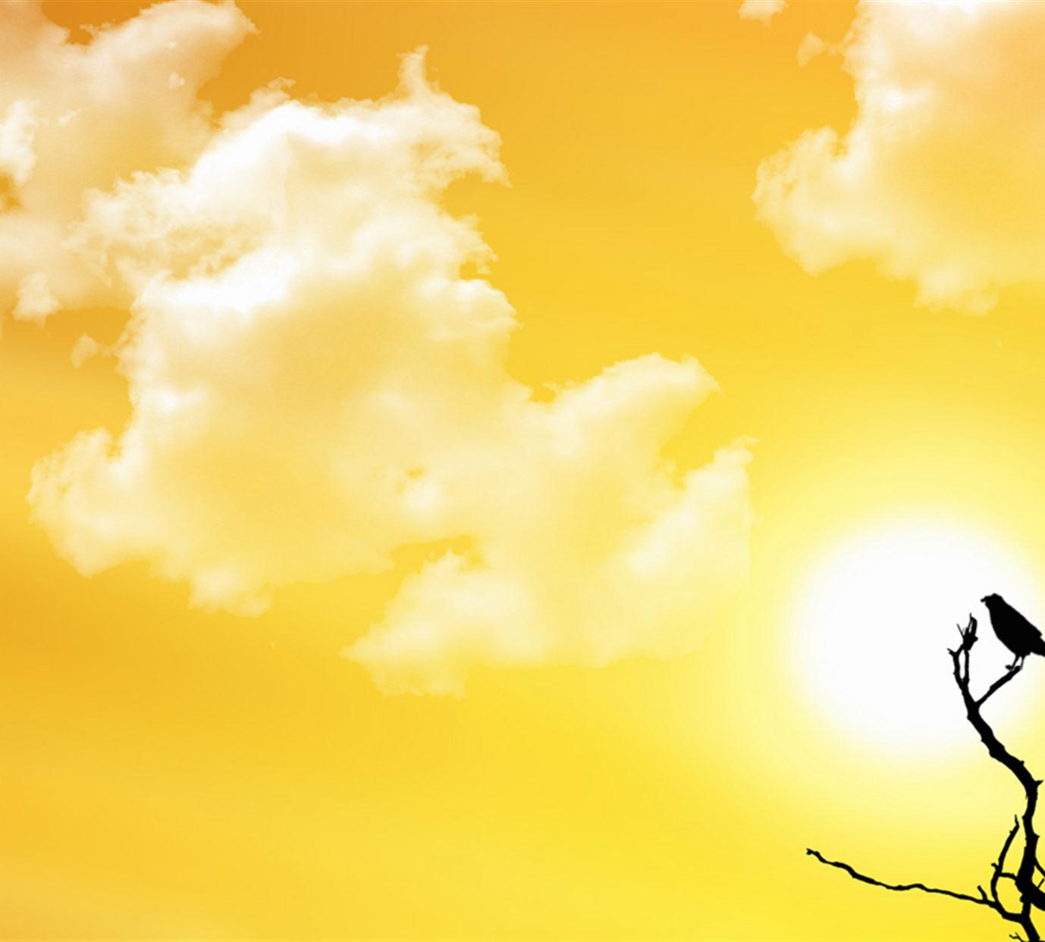

**Welcome to the Online Textbooks Section**

This online service offers easy access to the NCERT textbooks. The service covers textbooks of all subjects published by NCERT for classes I to XII in Hindi, English and Urdu. The Entire book or individual chapters can be downloaded provided the terms of use as mentioned in the Copyright Notice is adhered to.

***Copyright of NCERT Textbooks and terms of use***

Please note that the NCERT textbooks are copyrighted.

While copies of these textbooks may be downloaded and used as textbooks or for reference, republication of NCERT textbooks by any other individual or agency is strictly prohibited. No agency or individual may make electronic or print copies of these books and redistribute them in any form whatsoever. Use of these online books as a part of digital content packages or software is also strictly prohibited. No website or online service is permitted to host these online textbooks.

Links may however be provided with written permission from the NCERT.

|  |  |  |
| --- | --- | --- |
| **PLANTS** | **LIFE** | **WATER** |
| ALOVERA | 3 | 0.5 LITRE |
| TULSI | 2 | 1 LITRE |
| MINT | 1 | 2 LITRE |



**Discouraging Piracy**

In order to discourage piracy, the online textbooks carry a watermark on all pages declaring the copyright of NCERT. DO NOT BUY OR SELL electronic or printed books with watermarked pages.

**DHOKLIYA SCHOOLS**

Please bring to our notice any infringement or violation of copyright and commercial exploitation of these textbooks.

Join us in the Education for All mission . Help us reach these textbooks to children, teachers and schools.

Help us improve our services. Send your comments, suggestions or queries to [dceta.ncert@nic.in](mailto:dceta.ncert@nic.in)

In order to discourage piracy, the online textbooks carry a watermark on all pages declaring the copyright of NCERT. DO NOT BUY OR SELL electronic or printed books with watermarked pages.

Please bring to our notice any infringement or violation of copyright and commercial exploitation of these textbooks.

Join us in the Education for All mission . Help us reach these textbooks to children, teachers and schools.

Help us improve our services. Send your comments, suggestions or queries to dceta.ncert@nic.in

12 THE STD MATERIALS

lease bring to our notice any infringement or violation of copyright and commercial exploitation of these textbooks.

Join us in the Education for All mission . Help us reach these textbooks to children, teachers and schools.

|  |  |  |
| --- | --- | --- |
| **NAME** | **CONTACT** | **CITY** |
| JAY RAVAL | 53049803334 | RAJKOT |
| MEET RAVAL | 73049803334 | AHMEDABAD |
| HEET RAVAL | 63049803334 | WAKANER |

HTML,CSS,JS Nodejs ,Reactjs

Hello world